UI Animations

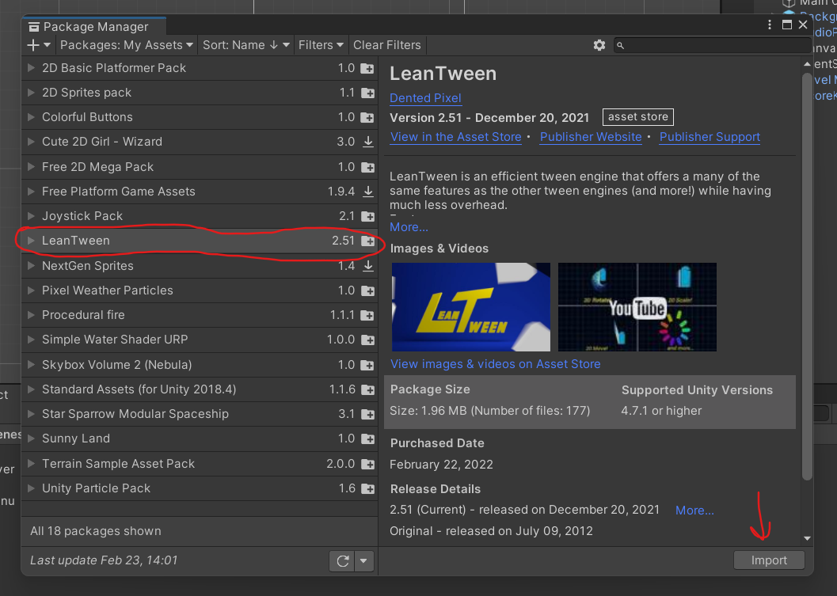

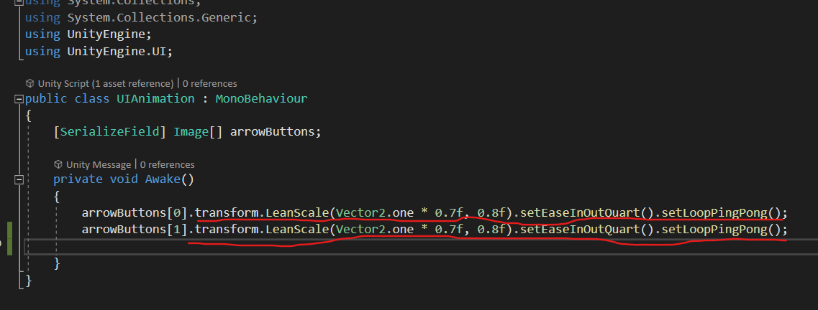

**LeanScale, LeanMove, LeanAlpha, etc.**

**To provide animations to UI elements. Uses Linear Interpolation to achieve animation.**

First parameter of any *Lean function* is the **final state** of the object. For eg.

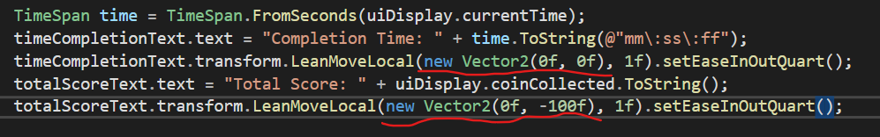

*new Vector2(0f, 0f)* is the target position for the animation and other parameter is the time duration of the UI animation.

Many more functions are there….

LeanTween Out of Space issue solution:

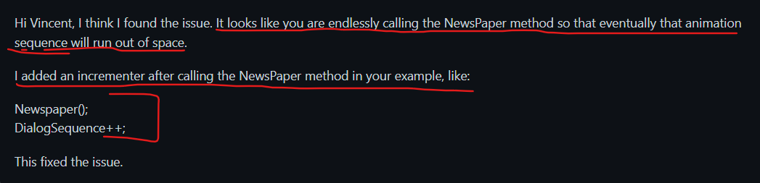

Note: Instead of declaring animation in update method, declare it out of the update function to avoid running out of space issue.